Examinations & Assessments
Results Issue – August 2023

Results for the programmes listed below will be available this year by logging into your NWRC online account (Prospect) using the following link:

https://ebsontrackprospect.nwrc.ac.uk/Page/U_LearnerExams

Awarding Organisation | Date Issued to Candidates | Method
RSL | Thursday 17 August 2023 from 8.30 am | - Online account  via Prospect
Pearson BTEC  Level 1 / Level 2 | Thursday 24 August 2023 from 8.30 am | - Online account  via Prospect
Pearson BTEC  Level 3 | Thursday 17 August 2023 from 8.30 am | - Online account  via Prospect
UAL | Thursday 17 August 2023 from 8.30 am | - Online account  via Prospect  - Result slips posted to candidates’ home address
GCSE | Thursday 24 August 2023 from 8.30 am | - Online account  via Prospect  - Result slips posted to candidates’ home address
Essential Skills | 8 weeks approximately after last date of exam series | - Online account  via Prospect  - Result slips posted to candidates’ home address
All other courses | Results will be posted to students’ home addresses when available

Sample of a results page via your online account:
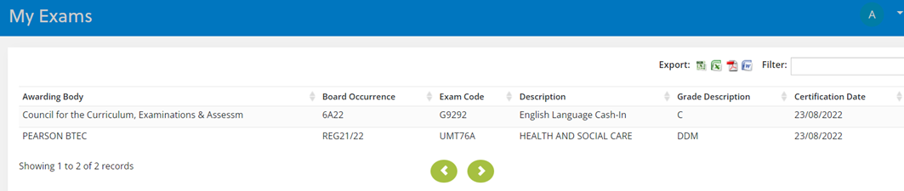

Your grade will be listed under the Grade Description column.

If you are accessing your online account via a mobile phone or tablet, you may need to select the Export option at the top right-hand side of the screen to view your result.

How to access your online account?
Please use the following link to access your NWRC online account: https://ebsontrackprospect.nwrc.ac.uk/Page/U_LearnerExams

Please note your ‘username' is the first part of the personal email address (up to the @ symbol) you used when first setting-up your online account. You will then have the option to reset your password if you have forgotten it.

Having difficulties logging in?
Visit the FAQ section of our www.nwrc.ac.uk/results page for information on how to log into your account. If you are still having difficulties, email IS.Helpdesk@nwrc.ac.uk.

Not happy with your results?
Visit the FAQ section of our www.nwrc.ac.uk/results page for further guidance.

-----

If you cannot see your results online, please do not worry.
You can email exams@nwrc.ac.uk with your full name, date of birth and course attended,
and our examinations staff will confirm your results to you via email.
You must email us directly as we cannot share your results with anyone else.

Please note, that due to the high volume of enquiries expected during Results Week,
it may take 24 – 48 hours for your query to be answered.

For additional information visit www.nwrc.ac.uk/results

