**Derry~Londonderry**

Strand Road, Londonderry, BT48 7AL

**Tel**. 028 7127 6000

**Fax**. 028 7126 0520

**Textphone** 028 7127 6167

*The College welcomes calls via Relay*

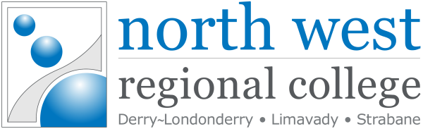

**Principal & Chief Executive**:

**Mr Leo Murphy** *BSc (Hons), DipAcc, DipEd, MBA, MCIM*

**www.nwrc.ac.uk info@nwrc.ac.uk**

December 2023

**Statement of Compliance**

**UK Modern Slavery Act 2015**

This is to confirm that North West Regional College and its subsidiaries have read and understood the UK Modern Slavery Act and will meet its requirements where possible.

As an organisation we are committed to safeguarding and promoting the welfare of learners, employees and volunteers, with a safeguarding policy and procedure in place covering all forms of exploitation, including slavery or practices similar to slavery.

Signature of Principal, Leo Murphy

***Leo Murphy***

***Principal & Chief Executive***