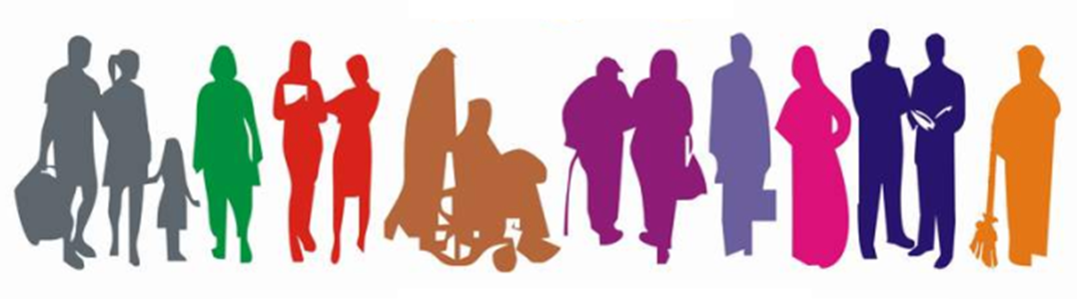

STUDENT Equality Information
2017/2018

Religious Belief
Description | Count | %
Roman Catholic | 8897 | 51.03%
None | 3174 | 18.20%
Not stated - MIS use only | 2662 | 15.27%
Presbyterian Church in Ireland | 1093 | 6.27%
Church of Ireland | 755 | 4.33%
Other Religion | 355 | 2.04%
Other Christian | 306 | 1.75%
Buddhist | 55 | 0.32%
Methodist | 53 | 0.30%
Muslim | 51 | 0.29%
Hindu | 16 | 0.09%
Other | 10 | 0.06%
Jewish | 5 | 0.03%
Sikh | 3 | 0.02%
Baptist | 1 | 0.01%
Grand Total | 17436 | 100.00%
Student Equality Data 2017-2018

Political Opinion
Description | Count | %
Not Stated - MIS use only | 6395 | 36.68%
Nationalist | 4179 | 23.97%
Prefer not to say | 3294 | 18.89%
None | 1461 | 8.38%
Other | 1055 | 6.05%
Unionist | 1052 | 6.03%
Grand Total | 17436 | 100.00%

Racial Group
Description | Count | % (inc white) | % (not inc white)
White | 16166 | 92.72% | -
Not stated - MIS use only | 957 | 5.48% | 76.99%
Mixed Ethnic Other | 87 | 0.50% | 6.85%
Any Other Ethnic Group | 74 | 0.42% | 5.83%
Black African | 33 | 0.19% | 2.60%
Indian | 27 | 0.15% | 2.13%
Black Other | 25 | 0.14% | 1.97%
Irish Traveller | 20 | 0.11% | 1.57%
Black Caribbean | 16 | 0.09% | 1.26%
Chinese | 16 | 0.09% | 1.26%
Pakistani | 13 | 0.07% | 1.02%
Other |  | 0.03% | 0.39%
Bangladeshi | 2 | 0.01% | 0.16%
Grand Total | 17436 | 100.00%

Age
Description | Count | %
18 and under | 6758 | 38.76%
19 to 30 | 5102 | 29.26%
31 to 40 | 2219 | 12.73%
41 to 50 | 1509 | 8.65%
51 to 60 | 988 | 5.67%
61 and over | 860 | 4.93%
Total | 17436 | 100.00%

Marital Status
Description | Count | %
Single | 12129 | 69.56%
Not stated - MIS use only | 2681 | 15.38%
Married | 1831 | 10.50%
In a civil partnership | 231 | 1.32%
Separated | 228 | 1.31%
Divorced/Dissolved | 218 | 1.25%
Widowed/Surviving partner | 110 | 0.63%
Other | 8 | 0.05%
Grand Total | 17436 | 100.00%

Sexual Orientation
Description | Count | %
Heterosexual/Straight | 12058 | 69.16%
Not stated - MIS use only | 3765 | 21.59%
Prefer not to say | 1229 | 7.05%
Bisexual | 169 | 0.97%
Gay | 111 | 0.64%
Lesbian | 92 | 0.53%
Other | 12 | 0.07%
Grand Total | 17436 | 100.00%

Gender
Description | Count | %
Female | 9123 | 52.32%
Male | 8310 | 47.66%
Other | 3 | 0.02%
Grand Total | 17436 | 100.00%

Disability
Description | Count | %
None | 13176 | 75.57%
Specific learning disability (eg dyslexia, dysgraphia) | 1531 | 8.78%
Disability, Special Need or Medical Condition | 1047 | 6.00%
Unseen Disability (eg diabetes, epilepsy) | 315 | 1.81%
Autistic spectrum disorder/Asperger's syndrome | 260 | 1.49%
Mental health difficulty | 213 | 1.22%
Unknown | 199 | 1.14%
Not Stated | 186 | 1.07%
Two or More | 181 | 1.04%
Wheelchair or mobility difficulty | 140 | 0.80%
Blind or partially sighted | 108 | 0.62%
Deaf or hard of hearing | 77 | 0.44%
Other | 3 | 0.02%
Grand Total | 17436 | 100.00%

Dependant Child
Description | Count | %
No | 16353 | 93.79%
Yes | 1083 | 6.21%
Grand Total | 17436 | 100.00%

Dependant Adult
Description | Count | %
No | 17235 | 98.85%
Yes | 201 | 1.15%
Grand Total | 17436 | 100.00%

Community Background
Description | Count | %
Roman Catholic | 9945 | 57.04%
Not stated - MIS use only | 3165 | 18.15%
Protestant | 2735 | 15.69%
No Religion | 1214 | 6.96%
Other Christian | 251 | 1.44%
Non-Christian | 118 | 0.68%
Other | 8 | 0.05%
Grand Total | 17436 | 100.00%

