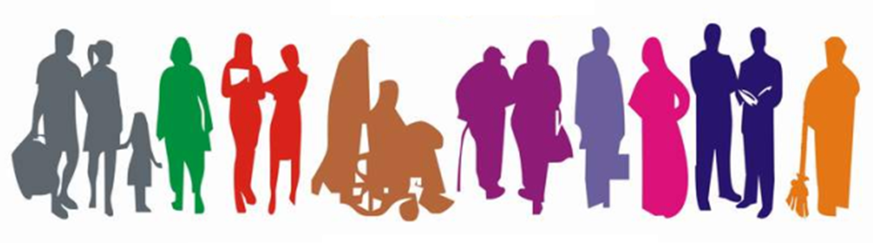

***STUDENT Equality Information***

***2018/2019***

**Student Equality Data 2018-2019**

|  |  |  |
| --- | --- | --- |
| Religious Belief |  |  |
| Description | **Count** | **%** |
| Roman Catholic | 8393 | 47.38% |
| Not Stated – MIS use only | 3463 | 19.55% |
| None | 3187 | 17.99% |
| Presbyterian Church in Ireland | 1150 | 6.49% |
| Church of Ireland | 656 | 3.70% |
| Other Religion | 387 | 2.18% |
| Other Christian | 284 | 1.60% |
| Methodist | 68 | 0.38% |
| Buddhist | 48 | 0.27% |
| Muslim | 38 | 0.21% |
| Jewish | 18 | 0.10% |
| Hindu | 16 | 0.09% |
| Sikh | 8 | 0.05% |
| Grand Total | 17716 | 100.00% |

|  |  |  |
| --- | --- | --- |
| Political Opinion |  |  |
| Description | **Count** | **%** |
| Not Stated - MIS use Only | 7277 | 41.08% |
| Nationalist | 3765 | 21.25% |
| None | 2985 | 16.85% |
| Prefer not to say | 1797 | 10.14% |
| Unionist | 998 | 5.63% |
| Other | 894 | 5.05% |
| Grand Total | 17716 | 100.00% |

|  |  |  |
| --- | --- | --- |
| Racial Group |  |  |
| Description | **Count** | **%** |
| White | 16431 | 92.75% |
| Not Stated - MIS use Only | 995 | 5.62% |
| Mixed Ethnic Other | 95 | 0.54% |
| Any Other Ethnic Group | 76 | 0.43% |
| Indian | 29 | 0.16% |
| Chinese | 20 | 0.11% |
| Pakistani | 19 | 0.11% |
| Black African | 17 | 0.10% |
| Irish Traveller | 16 | 0.09% |
| Black Other | 9 | 0.05% |
| Black Caribbean | 6 | 0.03% |
| Bangladeshi | 3 | 0.02% |
| Grand Total | 17716 | 100.00% |

|  |  |  |
| --- | --- | --- |
| Age |  |  |
| Description | **Count** | **%** |
| 18 and under | 6587 | 37.18% |
| 19 to 30 | 5516 | 31.14% |
| 31 to 40 | 2195 | 12.39% |
| 41 to 50 | 1648 | 9.30% |
| 51 to 60 | 977 | 5.51% |
| 61 and over | 793 | 4.48% |
| Total | 17716 | 100.00% |

|  |  |  |
| --- | --- | --- |
| Marital Status |  |  |
| Description | **Count** | **%** |
| Single | 12120 | 68.41% |
| Not Stated - MIS use Only | 3076 | 17.36% |
| Married | 1792 | 10.12% |
| In a civil partnership | 216 | 1.22% |
| Separated | 207 | 1.17% |
| Divorced/Dissolved | 188 | 1.06% |
| Widowed/Surviving partner | 117 | 0.66% |
| Grand Total | 17716 | 100.00% |

|  |  |  |
| --- | --- | --- |
| Sexual Orientation |  |  |
| Description | **Count** | **%** |
| Heterosexual / Straight | 11710 | 66.10% |
| Not Stated - MIS use Only | 4492 | 25.36% |
| Prefer not to say | 917 | 5.18% |
| Bisexual | 324 | 1.83% |
| Gay | 161 | 0.91% |
| Lesbian | 112 | 0.63% |
| Grand Total | 17716 | 100.00% |

|  |  |  |
| --- | --- | --- |
| Gender |  |  |
| Description | **Count** | **%** |
| Female | 9257 | 52.25% |
| Male | 8458 | 47.74% |
| Other | 1 | 0.01% |
| Grand Total | 17716 | 100.00% |

|  |  |  |
| --- | --- | --- |
| Disability |  |  |
| Description | **Count** | **%** |
| None | 13514 | 76.28% |
| Specific learning disability (eg dyslexia, dysgraphia) | 1795 | 10.13% |
| Disability, Special Need or Medical Condition | 708 | 4.00% |
| Unseen Disability (eg diabetes, epilepsy) | 367 | 2.07% |
| Autistic spectrum disorder/Asperger's syndrome | 364 | 2.05% |
| Mental health difficulty | 246 | 1.39% |
| Unknown | 172 | 0.97% |
| Not Stated | 152 | 0.86% |
| Wheelchair or mobility difficulty | 140 | 0.79% |
| Two or More | 103 | 0.58% |
| Deaf or hard of hearing | 78 | 0.44% |
| Blind or partially sighted | 77 | 0.43% |
| Grand Total | 17716 | 100.00% |

|  |  |  |
| --- | --- | --- |
| Dependant Child |  |  |
| Description | **Count** | **%** |
| No | 17299 | 97.65% |
| Yes | 417 | 2.35% |
| Grand Total | 17716 | 100.00% |

|  |  |  |
| --- | --- | --- |
| Dependant Adult |  |  |
| Description | **Count** | **%** |
| No | 17613 | 99.42% |
| Yes | 103 | 0.58% |
| Grand Total | 17716 | 100.00% |

Table showing number of students and their community background