Using NGT with a textphone
Not everyone wants to use a mobile, tablet, or computer to make their calls. If you want to carry on using your textphone (Minicom/ Uniphone), to make calls, that's fine. You can still make calls in the usual way.

All you need to do is dial 18001 followed by the phone number of the person you want to call

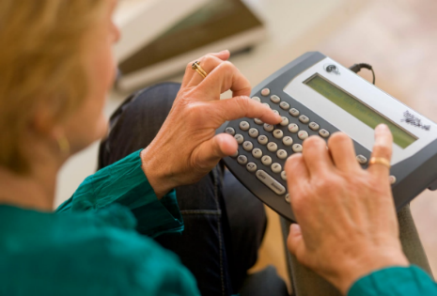
1. Dial 18001 followed by the phone number (including the dialling code)
You’ll see 'NGT ring ring' on your textphone screen. If your call is answered, you’ll see:
1. 'NGT Answered, please wait for connection'
2. 'NGT Waiting for a free relay assistant'
3. 'Connected to Text Relay, please wait'

The Relay Assistant won’t come on the call if it’s not answered.

2. Type your conversation
Once you're connected, you can type or speak your conversation. The Relay Assistant will type back anything the hearing person says.

3. Enjoy your chat
The conversation will carry on this way until one of you ends the call.

How to answer an NGT call on your textphone
It’s the same as answering other calls on your textphone except you’ll see some different messages.

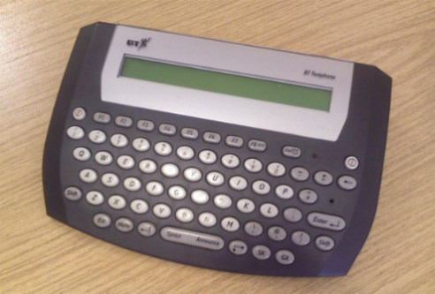
The textphone rings or flashes
You'll see 'NGT waiting for a free relay assistant', or 'NGT connected text to text' if the call was made from a textphone or the NGT app.

If the call is from a hearing telephone user, you'll then see 'Connected to Text Relay, please wait'.

Once you're connected, carry on as normal.

